**Đáp án bài thi trắc nghiệm Bảo trì phần mềm**

**( 20 câu – 15p )**

**Bài của Diễm Thúy**

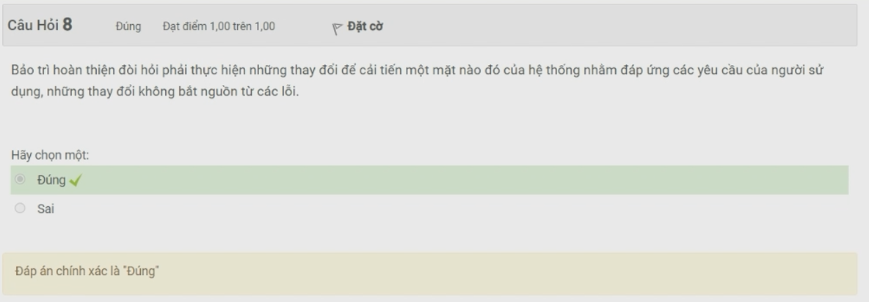

Bài làm của Thuận ( có thêm vài câu khác trên )



